**A3 Aims**

*Aims*

Our aim through this project is to create an iOS/Android named Australian Sports Manager. It’s function will be to input user’s data to categorise and store and sort players and officials to fit all relevant sporting schedules. Users will be able to nominate availabilities as players and officials which will then be used to sort teams and officials for each round of weekend sport. Its function is to create a stress free process in filling officials and players for the weekend. Personal information such as addresses, phone numbers and emails will be inputted to the app, as this is the key data that will be processed to help captains fill in missing players and officials.

To get started on this project, as a team we have come up with clear personal goals that we want to achieve:

*Goals*

**Investor Pitch**

This pitch will hopefully persuade potential investors to back our project. While we have an idea, at this moment that is all it is. An investor will help fund us to our project completion and will enable us to expand on our ideas to create the best product we can. Our approach to investors to receive backing will be a thorough business plan of our idea. What problems can it solve, and are they problems worth solving? Our pitch must reinforce and convince investors these problems and solutions matter, however niche the idea may be. Another emphasis shall be on our team, experts in all relevant areas of our project. Each team member will have all their strengths highlighted as we want investors to perceive our team and project in a light of high credibility, as this will put us in the best position to be backed.

**Website**

A website will enable us to spread word of mouth and promote our product before release. It will also offer customers a chance to get to know our team members and their personalities, giving a relatable and friendly face to our brand and product. All updates and new relevant information will be posted on the website. Reaching a wider audience is also a key component in wanting our website created. Having a website is essential to protect our business brand. Publishing an official website for our product will ensure us to protect and secure our business brand online.

**Marketing**

Marketing will be a key element in attracting our desired customer base, as well as expanding outward from them as well. Producers will know the specific needs and preferences of the people and the customers about the products that manufacturers can offer. If our marketing is successful it will also enable us to create more employment opportunities to expand our team to create a better service for our customers. Employees who are top of their respective fields will be added to create a more positive and hardworking environment which in turn will create more resources and opportunities for us to expand on what our initial premise is. Additional updates such as paying sports yearling subscription payments and import membership lists to ASM. These are just a few achievable additions that we are interested in adding to the application.

**User Interface**

A prototype user interface will be a good foundation to promote the accessibility and design of the project idea. It will also set the tone for what we want to achieve on our application as well as offer us multiple design opportunities that coincide with our vision. User interface design is directly linked to user experience. The goal of our UI is to create interaction as simple, fluid and efficient as possible. The more knowledge we can gain from the user, the more efficient the interface can be. Delivering the best user interface creates improvements in productivity. This productivity is reflected in both the user and the brand. With a user-friendly interface and easy navigation, the user decreases search time and increases satisfaction, fulfilling their needs in a fast and efficient way. The brand increases sales volume, improves customer loyalty and minimises costs and resources.

**Logo Design**

We plan to have a logo design and application design also. Our aim is too have snappy yet professional looking designs that will instantly instil what our product represents.

Prototype designs:

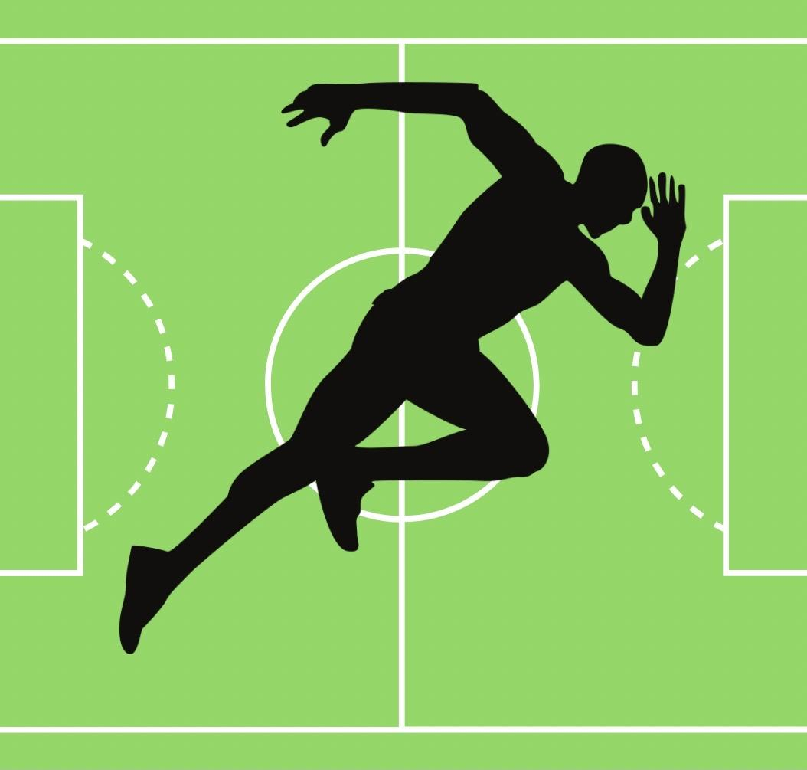

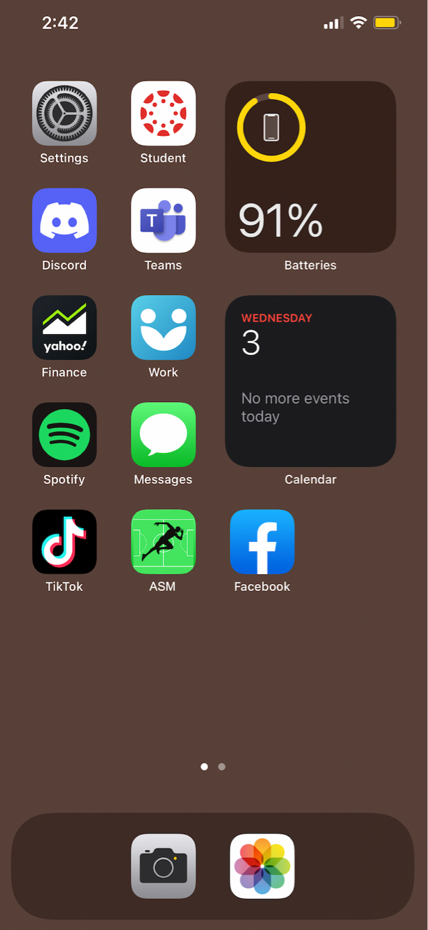

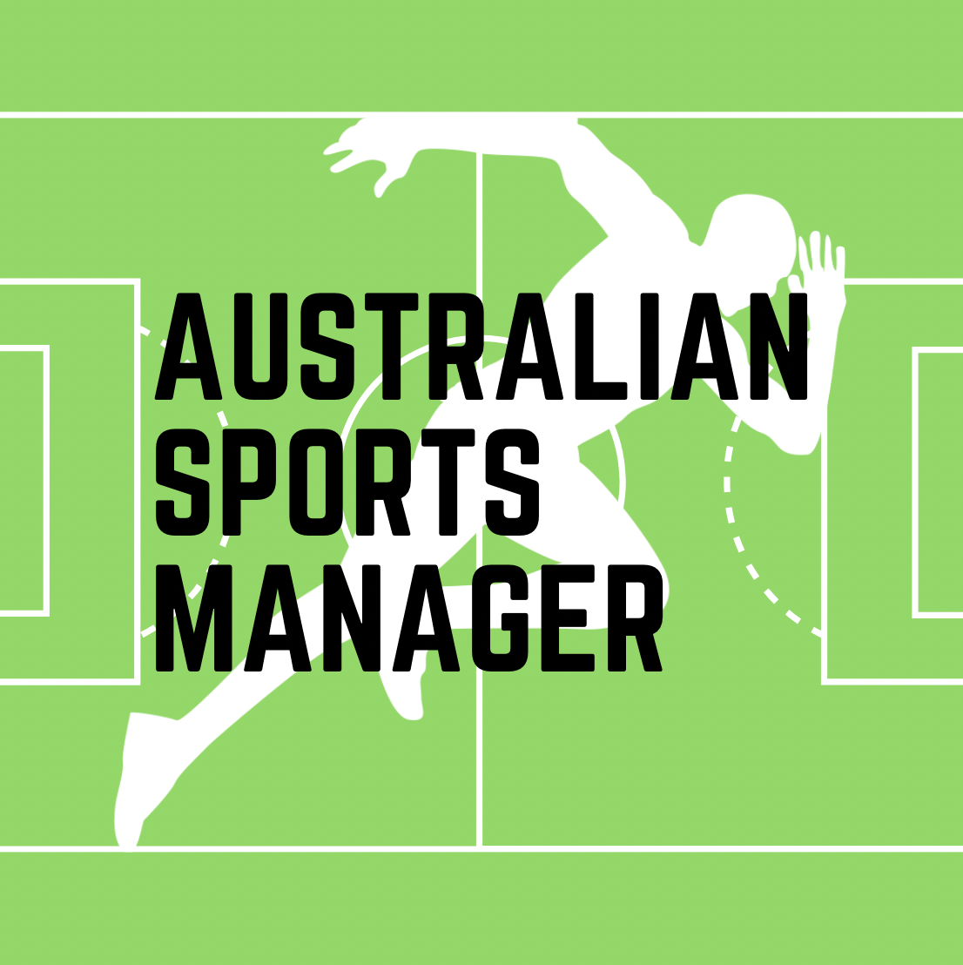

With these logos and designs we plan to create brand recognition. As you can see from all three prototypes, we have tried to create a consistent artistic style that we believe represents what our product is all about. We have created a design that can cover all sports, and that people with limited knowledge of sport or the field that we are trying to access could figure out what we are trying to sell at a small glance. We also feel it shows a sense of professionalism yet also conveys personality and branding for what we want our product wants to be seen as in the marketplace. The logos have a simplistic yet efficient tone to them, which is how we want to market our application and how we want user interaction to feel like while experiencing our project idea.

**Database**

A database will be crucial to how we underpin everything, as user data is core to how we want to run the application. An SQL database would be the ideal foundation, so we have set out to create a basic program in Python that can take user input data and categorise it in lists and sort and call relevant data when asked. If that is successful then we will import the SQL model around the code. With this Database Management System in place, it will allow for us to create a level of trust with our customers as there will be higher levels of data integrity, security, privacy and less data redundancy. Data consistency is what we are aiming for, and by achieving all of the above requisites we hope to achieve a high standard for our customers.